**Project Design Phase-II**

**Data Flow Diagram & User Stories**

|  |  |
| --- | --- |
| Date | 24 May 2023 |
| Team ID | NM2023TMID11242 |
| Project Name | Cognitive Care: Early Intervention for Alzheimer's Disease |

**Data Flow Diagrams:**

A Data Flow Diagram (DFD) is a traditional visual representation of the information flows within a system. A neat and clear DFD can depict the right amount of the system requirement graphically. It shows how data enters and leaves the system, what changes the information, and where data is stored.

**Example:** [**(Simplified)**](https://developer.ibm.com/patterns/visualize-unstructured-text/)

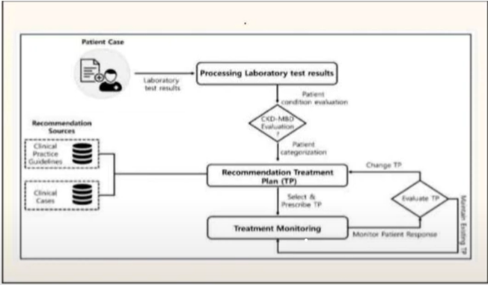

**User Stories**

| **User Type** | **Functional Requirement (Epic)** | **User Story Number** | **User Story / Task** | **Acceptance criteria** | **Priority** | **Team Member** |
| --- | --- | --- | --- | --- | --- | --- |
| Caregiver | Access to educational resources | USN-1 | As a caregiver, I want access to educational resources and support groups so that I can better understand and cope with the challenges of caring for my loved one with Alzheimer’s disease. | I can check the status. | High | Harikumar |
| Customer | Mobile application | USN-2 | As a person with early stage Alzheimer’s, I want a mobile application that provides reminders for daily tasks, medication schedules, and important appointments to help me maintain my independence and stay organized. | I can check the status. | High | Nivetha |
| Family member | Online platform | USN-3 | As a family member, I want an online platform where I can securely store and share my loved one’s medical information, including diagnostic, medications, and contact details of healthcare professionals to ensure coordinates care among the care giving team. | I can check the status. | High | Abirami |
| Researcher | Comprehensive database | USN-4 | As a researcher, I need a comprehensive database of anonymized patient data and biomarkers to facilitate my study on identifying early diagnostic markers and potential treatment targets for Alzheimer’s disease. | I can check the status. |  | Deepika sri |